There are many people that struggle with mental health issues due to societal standards and other undesirable circumstances. I have struggled with my own mental health issues in the past and want to be able to help people who are fighting their own battles as well. I will use my human relations degree to become a Licensed Professional Counselor (LPC) and help people

understand their problems, help them get through them, and answer their questions.

People often decide not to see a counselor or therapist for many reasons. It may be because it is too expensive, they do not have enough time, because it can be weird to tell your personal feelings to a stranger, and many other reasons (Soeiro, 2017). There is a stigma around going to a counselor or therapist, and it is important that we break it. Getting yourself help or seeking a counselor is nothing to be ashamed of. It is estimated that about half of Americans deal with a mental illness but do not receive treatment for it (Ellis, 2019). The stigma needs to be broken so that there are not so many people that are dealing with issues alone.

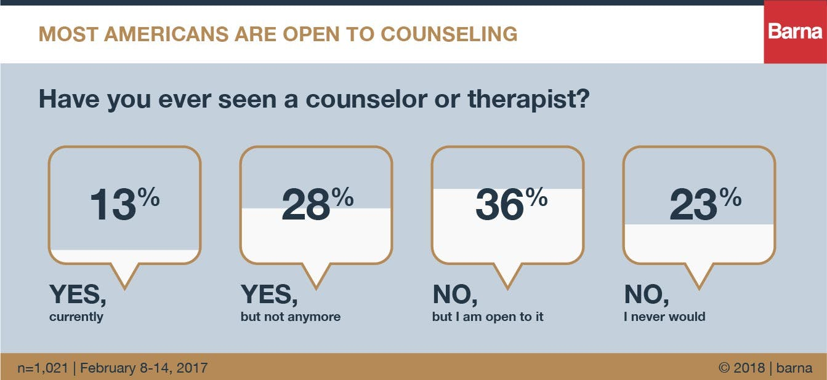

Licensed professional counselors (LPCs) have master’s degrees and are mental health service providers. They are trained to work with children, families, people who have addictions, mental illnesses, criminal records, disabilities, and they also work with groups in treating mental, behavioral, and emotional problems and disorders (ACA, 2011). LPCs diagnose and treat mental and emotional disorders, including addictive disorders, and mental illnesses. They also provide clinical therapy to clients in individual and group settings. In order to be an LPC, you will need a master’s degree, so my future plans are to receive a master’s degree in social work and to fulfill my dreams of becoming a licensed counselor.

References

ACA. (2011). Who Are Licensed Professional Counselors. *American Counseling Association*. <https://www.counseling.org/PublicPolicy/WhoAreLPCs.pdf>.

Barna Group. (2018). Americans Feel Good About Counseling. Barna Access. <https://www.barna.com/research/americans-feel-good-counseling/>.

Ellis, M. (2019). The Real Cost of Untreated Mental Illness in America. *Constellation Behavioral Health*. <https://www.constellationbehavioralhealth.com/blog/the-real-cost-of-untreated-mental-illness-in-america/>.

Soeiro, L. (2017). 10 Reasons Why People Refuse to Talk to Therapists. *Psychology Today*. <https://www.psychologytoday.com/us/blog/i-hear-you/201710/10-reasons-why-people-refuse-talk-therapists>.